- Start by navigating to your Azure resource group (e.g., evan12345) in the Azure Portal and create your Data Factory, SQL Database, and Storage account resources.
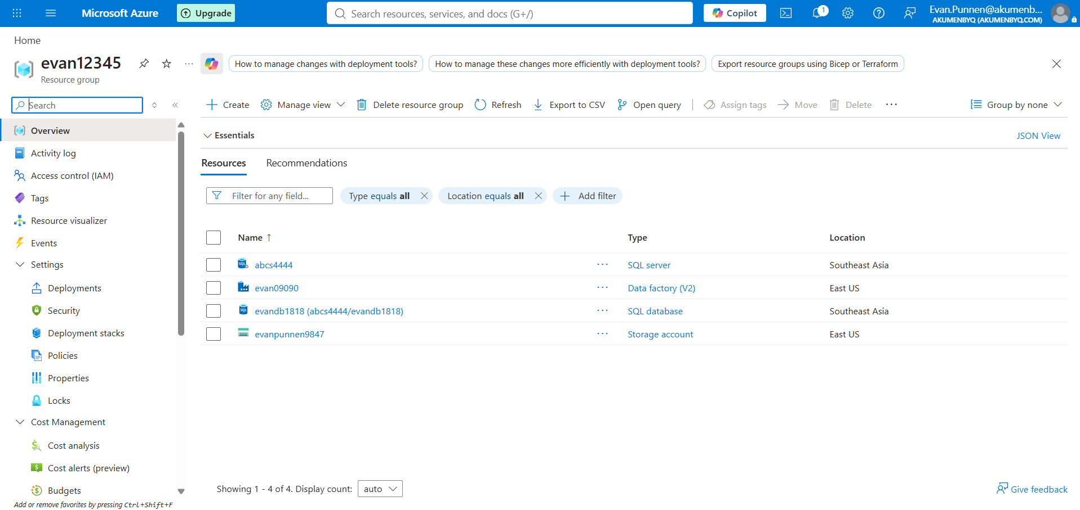
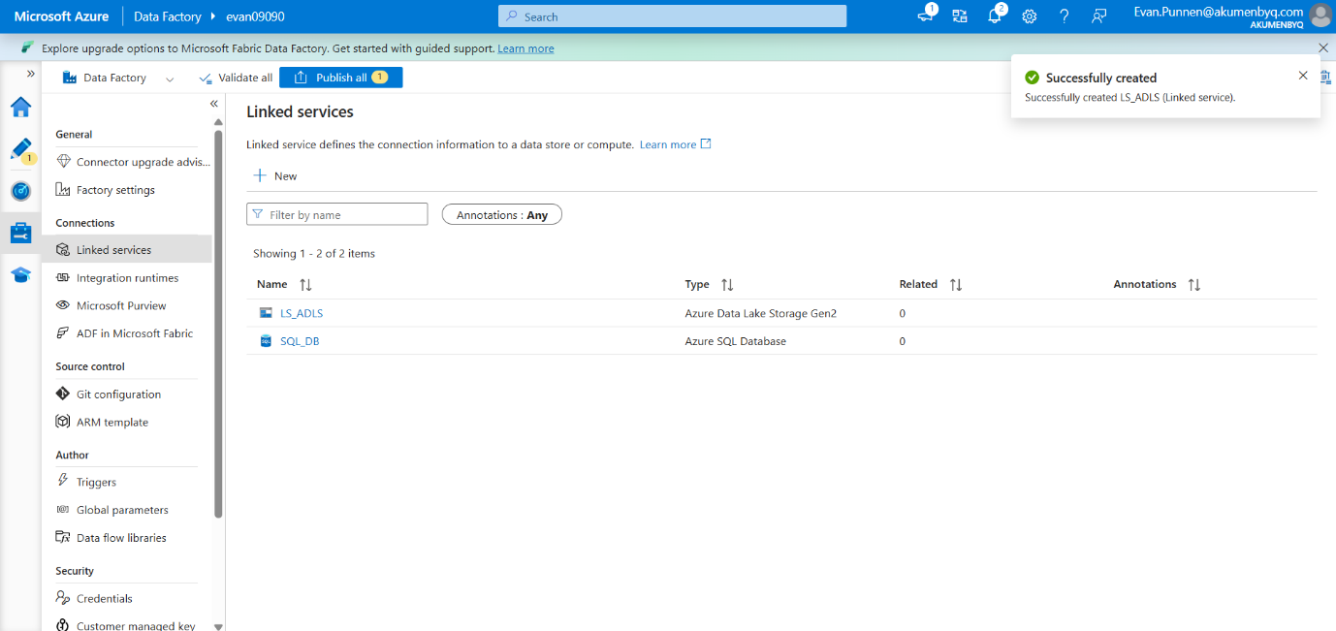
- Open Azure Data Factory Studio and create two Linked Services: one for Azure SQL Database (SQL_DB) to connect to your source, and one for Azure Data Lake Storage Gen2 (LS_ADLS) to connect to your destination.

- Create a new pipeline (e.g., pipeline1) and drag a Lookup activity onto the canvas. Name it lookup_olddata and configure it to fetch the last recorded watermark value from your database.
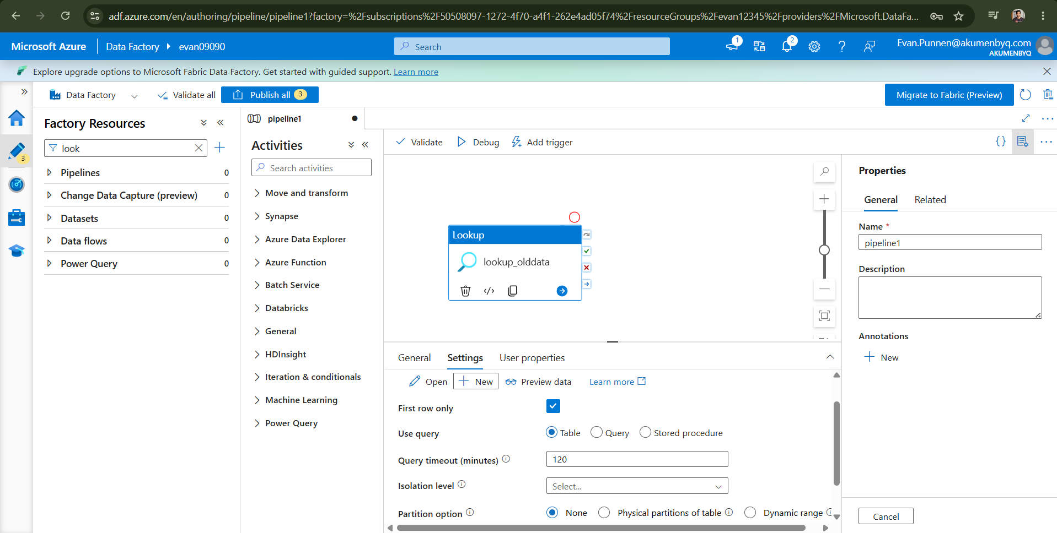
- Drag a second Lookup activity onto the canvas, name it lookup_newdata, and set its dataset to your SQL source (DS_SQL1). Configure it to use a query to find the maximum timestamp in your source table:

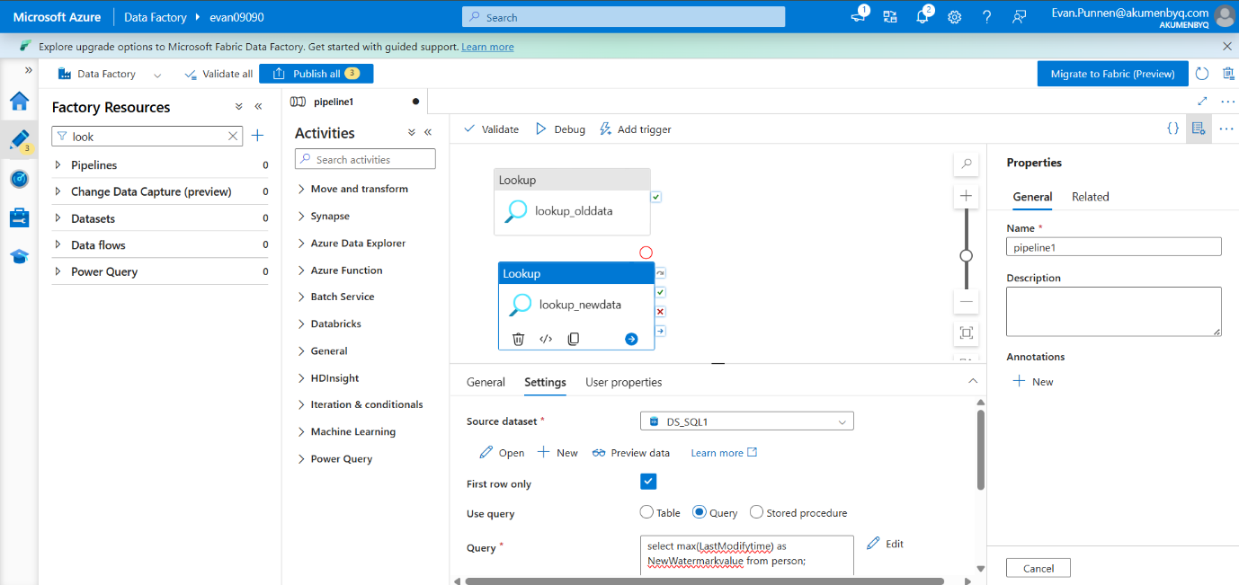

- Add a Copy data activity to the pipeline and connect the success outputs of both Lookup activities to it.
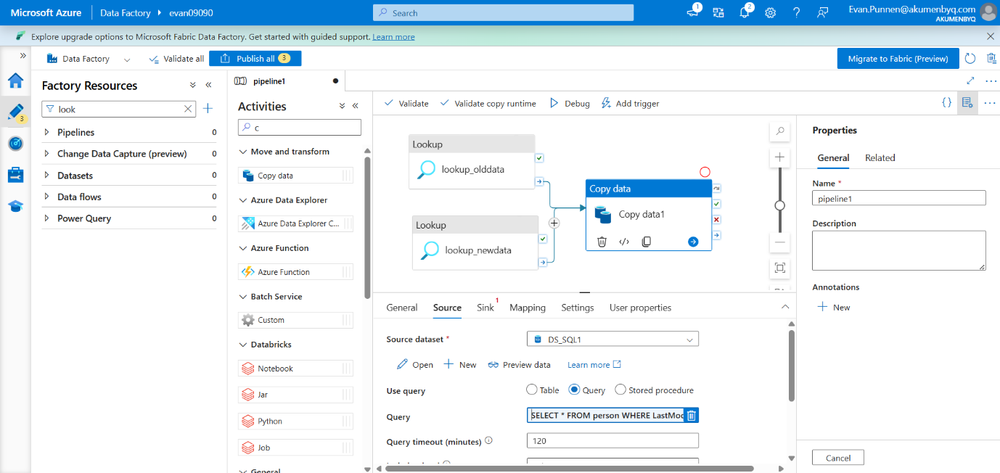
- In the Copy data Source tab, select your SQL dataset and choose the Query option. Open the pipeline expression builder and enter a dynamic query to select only records modified between the old and new watermarks:
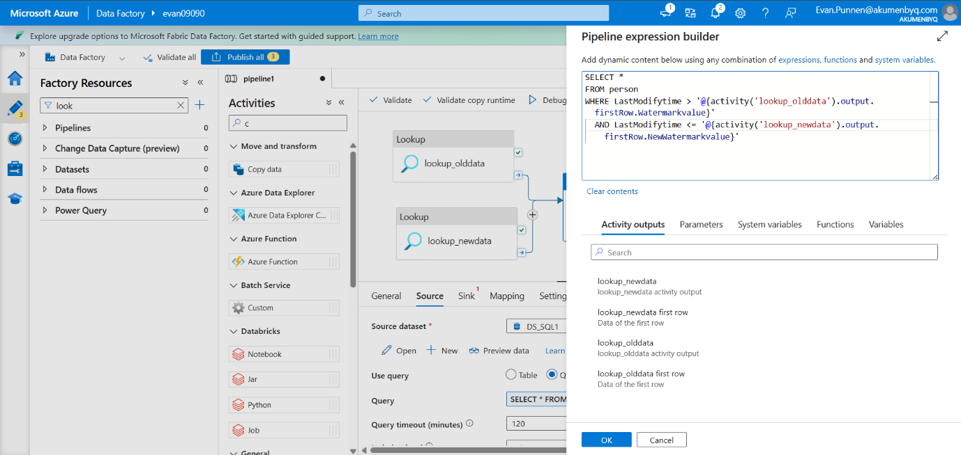

In the Copy data Sink tab, select your Data Lake dataset (DS_ADLF). Ensure the file path points to your output container and set the file extension - .csv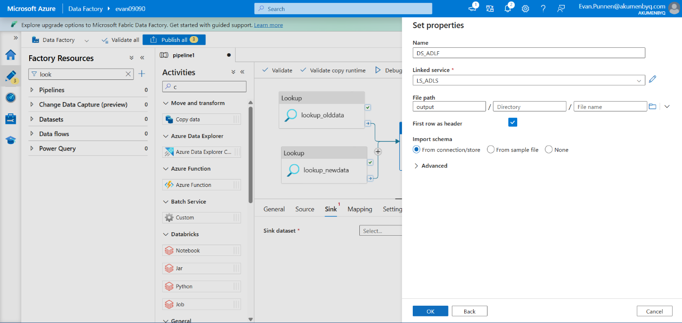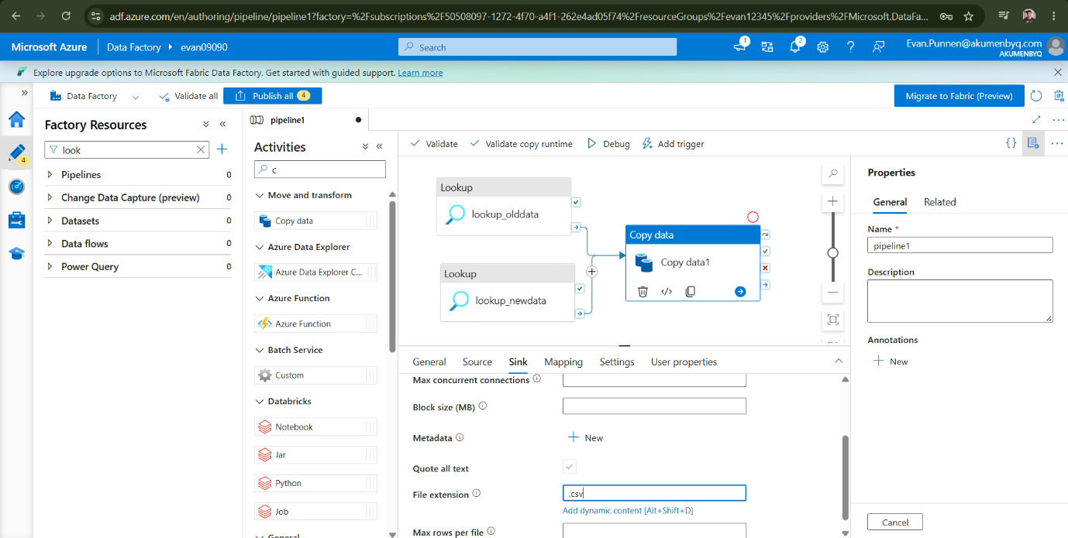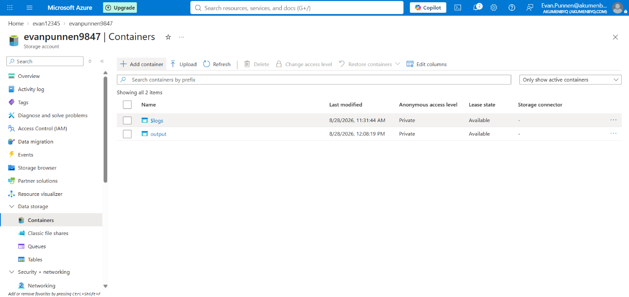

- Add a Stored procedure activity after the Copy data activity and link it to the Copy data success output.
- In the Stored procedure Settings tab, select your SQL database linked service and choose the stored procedure name [dbo].[write_watermarktable].
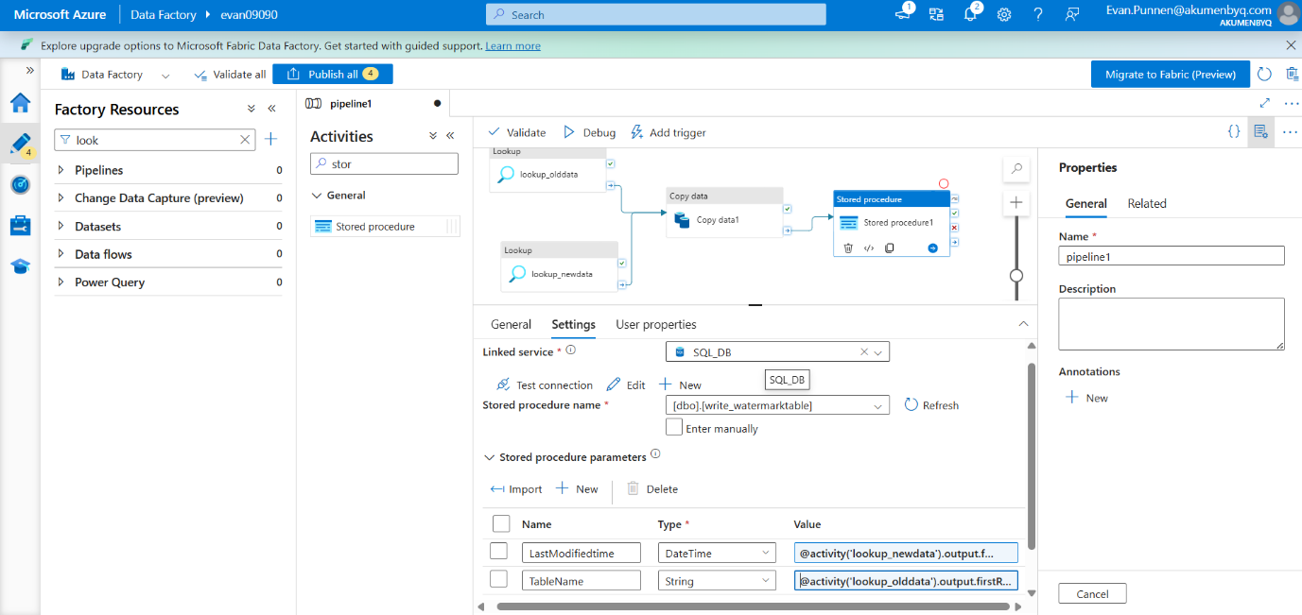
- Pass the pipeline values into the stored procedure parameters: map the LastModifiedtime parameter to the dynamic output of lookup_newdata, and map the TableName parameter to the dynamic output of lookup_olddata
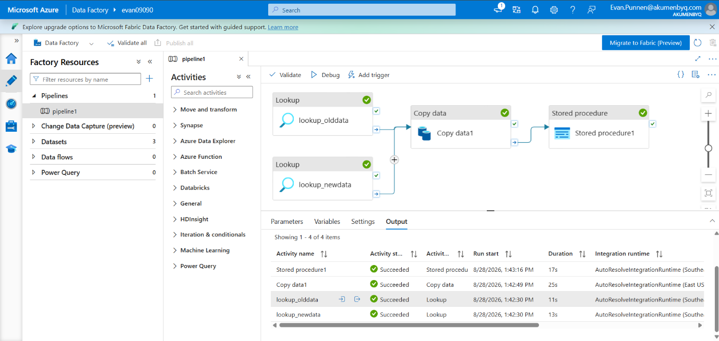
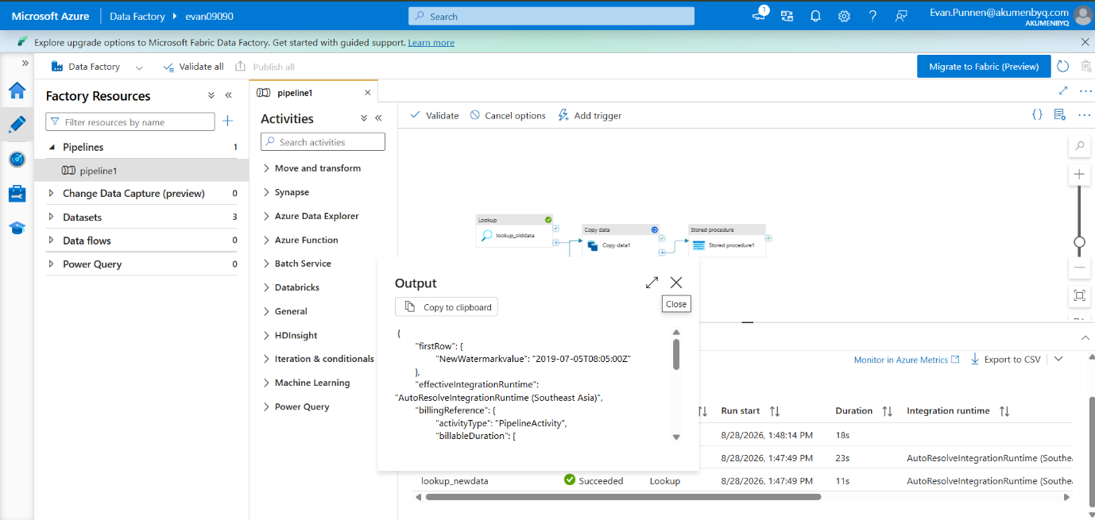
- Click Debug to trigger a test run of the pipeline. Click the output icon next to the lookup activities to verify the JSON payload correctly retrieved the Watermarkvalue and NewWatermarkvalue.
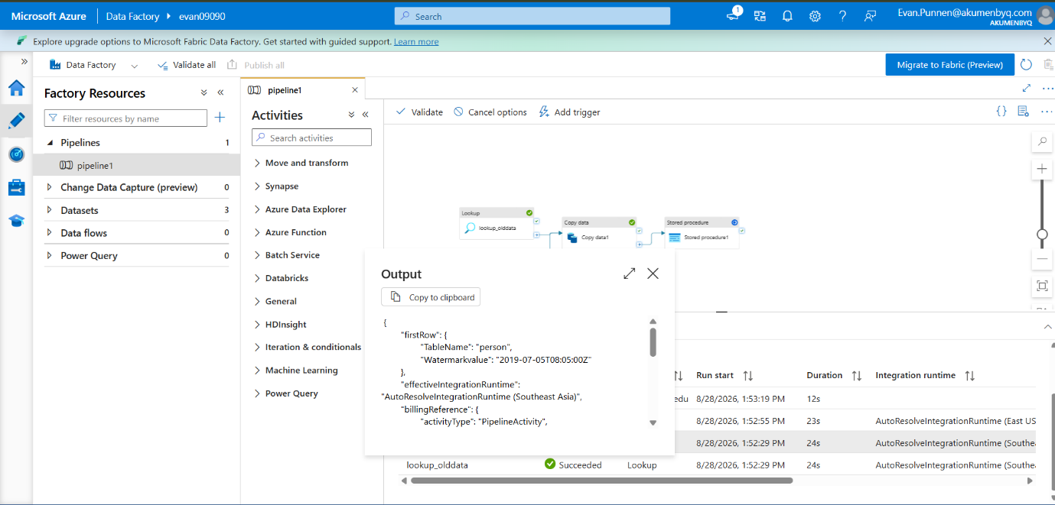

- Go to the Azure SQL Database query editor in the Azure Portal and execute an INSERT statement to add new records with fresh timestamps into your person table.
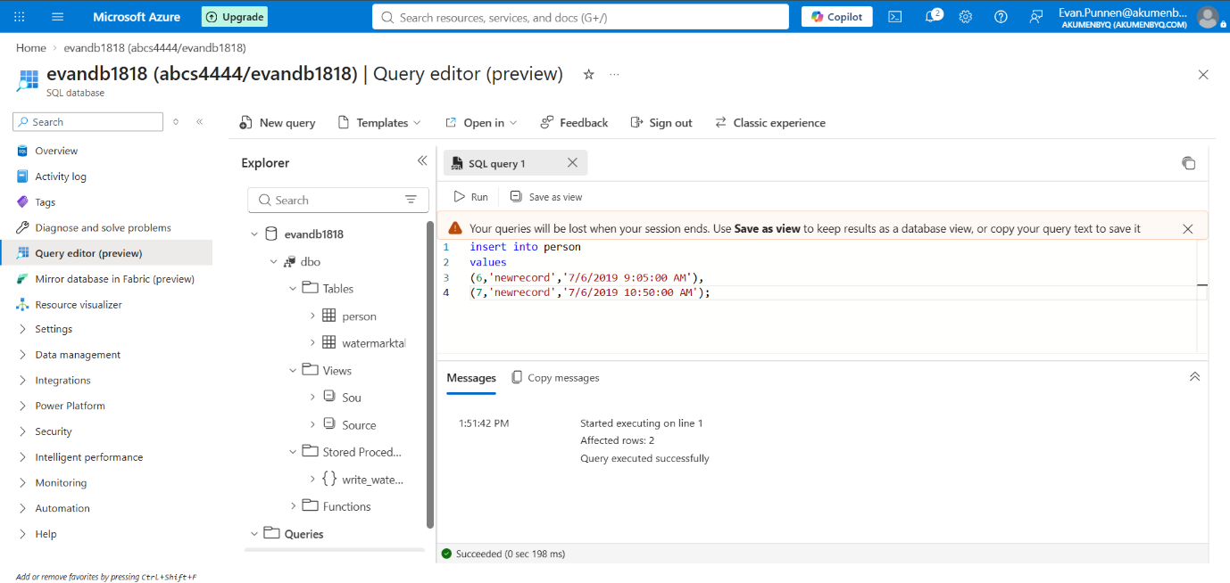
- Trigger another Debug run in Data Factory to test the incremental load. Once finished, click the output icon on the Copy data activity to confirm that the rows Copied matches the exact number of new records you just inserted.
